Cognitive tests and Questionnaire

Vocabulary learning

Next, you will see a page with pictures of different creatures. Under each picture you will see the name of that creature. Try to learn the names of all the creatures as best as you can. For this you will have 2,5 minutes. You will see the timer count down, so you can keep track of how much time you have left. When the time runs out the page will automatically move on to the next instruction.

For this test you are not allowed to take any notes. Try to remember the names all by yourself.

Click to start whenever you are ready.

Immediate recall

You will now see the names of the creatures on the left and their pictures on the right. Drag the names under the correct pictures. Make sure that you only have one name per picture. You will have 3 minutes and 30 seconds to complete this question.

Delayed recall

You will now see the names of the creatures from the start of this session again. You will see their names on the left and their pictures on the right. Drag the names under the correct pictures. Make sure that you only have one name per picture. You will have 3 minutes and 30 seconds to complete this question.

Version 1

Version 2

Logical reasoning

For each question you will see two statements and a conclusion. You will have to decide whether the conclusion follows from the statements. In other words: is the third sentence a certain and correct conclusion based on the first two sentences?

If the conclusion is correct and certain based on the sentences you choose YES, if the conclusion does not follow from the sentences you choose NO.

You will get 5 minutes to answer the questions.

Example:
If it is a ball it is large
It is large
It is a ball
Yes No

Here you indicate if the conclusion “It is a ball” follows logically and certainly from the first two statements “If it is a ball it is large” and “It is large”.

During this test you are allowed to take notes. You can start the test when you are ready.

Version 1

1 | If it is a square then it is not yellow | It is a square | It is not yellow | YES | NO
2 | If it is a triangle then it is yellow | It is yellow | It is a triangle | YES | NO
3 | If it is a circle then it is not green | It is not green | It is a circle | YES | NO
4 | If it is a diamond then it is green | It is a diamond | It is green | YES | NO
5 | If it is not a square then it is not green | It is not green | It is not a square | YES | NO
6 | If it is not a triangle then it is green | It is not a triangle | It is green | YES | NO
7 | If it is not a diamond then it is not red | It is a diamond | It is red | YES | NO
8 | If it is not a diamond then it is yellow | It is yellow | It is not a diamond | YES | NO
9 | If it is not a circle then it is not yellow | It is not a circle | It is not yellow | YES | NO
10 | If it is a triangle then it is not red | It is not a triangle | It is red | YES | NO
11 | If it is a circle then it is red | It is not red | It is not a circle | YES | NO
12 | If it is a square then it is blue | It is not a square | It is not blue | YES | NO
13 | If it is not a square then it is red | It is not red | It is a square | YES | NO
14 | If it is not a triangle then it is not blue | It is blue | It is a triangle | YES | NO
15 | If it is a diamond then it is not blue | It is blue | It is not a diamond | YES | NO
16 | If it is not a circle then it is blue | It is a circle | It is not blue | YES | NO

Version 2

1 | If it is an oval then it is not black | It is an oval | It is not black | YES | NO
2 | If it is a hexagon then it is black | It is black | It is a hexagon | YES | NO
3 | If it is a rectangle then it is not pink | It is not pink | It is a rectangle | YES | NO
4 | If it is a star then it is pink | It is a star | It is pink | YES | NO
5 | If it is not an oval then it is not pink | It is not pink | It is not an oval | YES | NO
6 | If it is not a hexagon then it is pink | It is not a hexagon | It is pink | YES | NO
7 | If it is not a star then it is not orange | It is a star | It is orange | YES | NO
8 | If it is not a star then it is black | It is black | It is not a star | YES | NO
9 | If it is not a rectangle then it is not black | It is not a rectangle | It is not black | YES | NO
10 | If it is a hexagon then it is not orange | It is not a hexagon | It is orange | YES | NO
11 | If it is a rectangle then it is orange | It is not orange | It is not a rectangle | YES | NO
12 | If it is an oval then it is purple | It is not an oval | It is not purple | YES | NO
13 | If it is not an oval then it is orange | It is not orange | It is an oval | YES | NO
14 | If it is not a hexagon then it is not purple | It is purple | It is a hexagon | YES | NO
15 | If it is a star then it is not purple | It is purple | It is not a star | YES | NO
16 | If it is not a rectangle then it is purple | It is a rectangle | It is not purple | YES | NO

Grammar learning

In this test you will see three blocks of examples followed by questions. Use the examples to answer the questions. You are also allowed to look back to previous examples or questions when answering later questions.

Each example shows 3 pictures with a sentence next to each picture. The sentence is describing the picture in a made-up language. Use these 3 example pictures to answer the next 5 questions. Each questions will show you a picture, and asks you to select the sentence from the options on the right that is describing the picture correctly in the grammar of the made-up language.

The last block of questions has no examples. Use your knowledge of the language and the previous questions and examples to answer these questions.

Try to answer the questions as accurately and as quickly as you can. Please time your test with a stopwatch and write down the time it took you to complete the test once you are finished.

You can start now.

Example 1

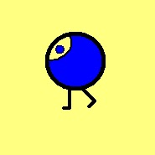

atak-arap-sa

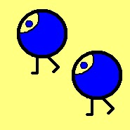

atak-arap

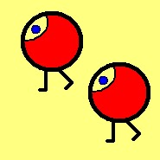

ipot-arap

Questions 1-5
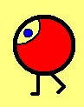

- ipot-arap
- ipot-arap-sa
- arap-ipot-sa
- arap-ipot

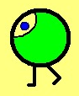
- atak-eket-sa
- eket-arap
- eket-arap-sa
- atak-eket

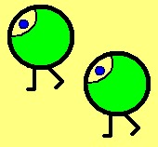

- eket-arap
- arap-eket
- eket-arap-ek
- ipot-eket

- arap-atak
- arap-atak-sa
- atak-arap-sa
- atak-arap

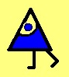
- atag-orad-za
- orad-atag-za
- orad-arap-za
- atag-orad

Example 2
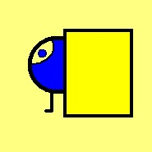

umush atak-arap-sa

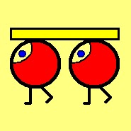

unak-ek ipot-arap

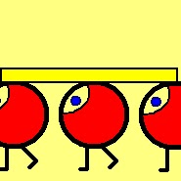

unak-em ipot-arap

Questions 6-10

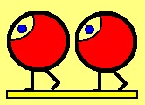

- inut ipot-arap
- inut-em arap-ipot
- inut-ek arap-ipot
- inut-ek ipot-arap

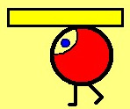

- unak ipot-arap-sa
- unak-sa ipot-arap
- unak-sa ipot-arap-sa
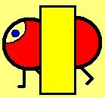
- unak ipot-arap

- ipot-arap umush-ek
- umush-ek ipot-arap
- umush ipot-arap
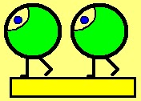
- umush-em ipot-arap

- inut-ek eket-arap
- eket-ek inut-arap
- inut-ek arap-eket
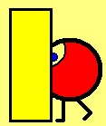
- inut eket-arap-sa

- umush ipot-arap
- umush-ek ipot-arap-sa
- umush ipot-arap-sa
- umush-sa ipot-arap
Example 3

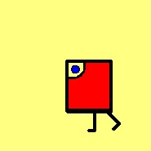

ipod-ilad-za

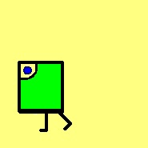

eked-ilad-za

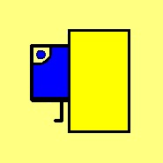

umush atag-ilad-za

Questions 11-15

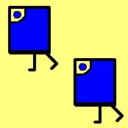

- ek atag-ilad
- ilad-atag
- atag-ek ilad
- atag-ilad

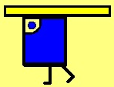

a) atag-ilad-za unak
b) unak atag-ilad-za
c) unak atak-ilad-sa
d) unak-za atag-ilad

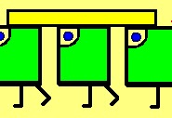

a) unak-ek eked-ilad
b) unak-em eked-ilad
c) unak-ek ilad-eked
d) unak-em eket-ilad

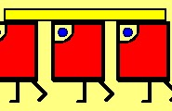

a) ipod-ilad unak-em
b) unak-em ipot-ilad
c) unak ipod-ilad
d) unak-em ipod-ilad

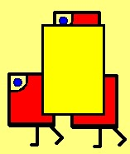

- umush-em ipod-ilad
- umush-ek ipod-ilad
- umush-ek ipot-ilad
- umush-em ipod-ilad

(No examples for these questions)

Question 16-20
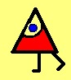
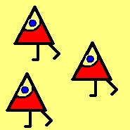
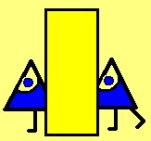
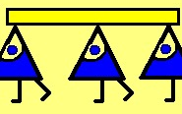
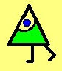
- ipod-orad
- ipod-orad-za
- ipot-orad
- ipot-orad-za

- orad-eked-za
- orad-eket-sa
- eked-orad-za
- eket-orad-sa

- umush-ek atag-orad
- umush atag-orad
- atag-orad umush-ek
- umush-em atag-orad

- unak-em orad-atag
- unak-ek atag-orad
- unak-ek orad-atag
- unak-em atag-orad

- em ipod-orad
- ipod-orad-em
- ipod-orad-za
- ipod-orad

Demographics

The following questions ask about your background and your previous programming experience. All answers are stored anonymously.

1 What is your age?
2 What gender do you identify as?
- Male
- Female
- Other
- Prefer not to say

3 Is COMP115 your first programming experience?
- Yes
- No

4 How would you rate your fluency in English?
 |  |  | Minimal | Moderate | Good | Fluent | Native
My fluency in English is

7 What is your main area of study?
Please select the answer that best describes your main area of study.
- Science
- Business
- Education
- Engineering and IT
- Environment
- Health and medical sciences
- Law, security and intelligence
- Media, creative arts and communication
- Society, history and languages
- Other:

9 Select your level of proficiency for each of the listed programming languages.

 | None | Minimal | Moderate | Good | Very good | Excellent
Python
Java
Scratch
C++
C
Racket/Scheme
Jython
Java script
Alice
Jerloo
LightBot
Snap
Bootstrap
Processing
Visual Basic
Matlab/Octave
R
Other

Post-test probe questions

The next two questions are for us to check whether we can use your tests as part of the research study. Your answers to these questions will not affect anything in your programming unit. Please answer honestly, so that we can guarantee the quality of our research.

2 Did you use the internet or a calculator to answer any of the questions on the test?
- Yes
- No

3 Did you use the help of other people (fellow students, friends family etc) to answer any of the questions?
- Yes
- No

4 Did you attempt to answer the questions on these tests seriously?
- I tried to answer all questions as best as I could
- I tried to answer most questions as best as I could
- I did not try to answer the questions seriously
- I answered most questions randomly
- Other

